RITCHIE RECYCLING & DISPOSAL
OVER THE BAG LIMIT WASTE PICK UPS

URBAN & RURAL CURBSIDE PICK UP

BULKY ITEM PICK UP

TEMPORARY BIN RENTALS
- WASTE OR RECYCLING -

FREE TIRE & EWASTE DROP OFF

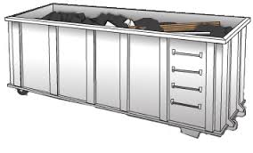

WE BUY SCRAP METAL!

Monday – Friday 8am – 5pm
5 1 9 - 3 5 2 - 1 1 1 3
r i t c h i e r e c y c l i n g @ m a i l . c o m
9430 McNAUGHTON LINE CHATHAM
Locally owned and operated since 2008

OVER THE BAG LIMIT WASTE PICK UPS

URBAN & RURAL CURBSIDE PICK UP

BULKY ITEM PICK UP

TEMPORARY BIN RENTALS
- WASTE OR RECYCLING -

FREE TIRE & EWASTE DROP OFF

OVER THE BAG LIMIT WASTE PICK UPS

URBAN & RURAL CURBSIDE PICK UP

BULKY ITEM PICK UP

TEMPORARY BIN RENTALS
- WASTE OR RECYCLING -

FREE TIRE & EWASTE DROP OFF

OVER THE BAG LIMIT WASTE PICK UPS

URBAN & RURAL CURBSIDE PICK UP

BULKY ITEM PICK UP

TEMPORARY BIN RENTALS
- WASTE OR RECYCLING -

FREE TIRE & EWASTE DROP OFF

